Academic Year 2022-23

PVKN Govt. College (A), Chittoor.
Department of English
B.A/B.Sc/B.Com SEMESTER-I
English Praxis Course-I (REVISED 2022-2023)
A Course in Communication and Soft Skills
22-ENG-1C1
AUTONOMOUS SYLLABUS

Learning Outcomes: By the end of the course the learner will be able to :
- Understand the importance of listening and develop listening skill.
- Use grammar effectively in writing and speaking.
- Demonstrate the use of good vocabulary
- Demonstrate an understating of writing skills
- Acquire ability to use Soft Skills in professional and daily life.
- Confidently use the tools of communication skills

I. UNIT: Listening Skills
- Importance and types of listening
- Barriers to Listening
- Measures for Effective Listening

II. UNIT: Speaking Skills
- Sounds of English: Vowels and Consonants
- Syllables
- Intonation

III. UNIT: Text
- The Model Millionaire (Prose)- Oscar Wilde
- The Violin (Short story) - Chaganti Somayajulu

c. The Gift Of India(Poem)- Sarojini Naidu

IV. UNIT: Soft Skills
- SWOC
- Attitude
- Emotional Intelligence

V. UNIT: Grammar
- Articles
- Parts of Speech
- Tenses(Present/Past/Future

PVKN Govt. College(A), Chittoor
Three Year B.A/B.Sc/B.Com Degree Examination UG Semester-II
Choice Based Credit System (Revised- 2022-23)
English Praxis Course-II: A Course in Reading & Writing Skills
Paper Code: 22-ENG-2C2 Autonomous syllabus
UNIT-I
Skills: 1.Vocabulary: ConversionofWords2.OneWordSubstitutes 3.Collocations
UNIT-II
Poetry Skills : 1Ode on Grecian Urn-John Keats
Non-Detailed Text : 2. God Sees The Truth, But Waits - Leo Tolstoy
Skills : 3. Skimming and Scanning
UNIT-III
Prose Skills :
1. Of Truth- Fransis Bacon
- Reading Comprehension
- Note Making/Taking

UNIT- IV
Poetry Skills : 1. Coromandel Fishers- Sarojini Naidu
- Expansion of Ideas
- Notices, Agendas and Minutes
UNIT-V
Non-DetailedText : 1. An Astrologer's Day - RKNarayan
Skills: 2. Curriculum Vitae and Resume:
3. Letters &E-Correspondence

PVKN.Govt.College(A), Chittoor.
Department of English
B.A/B.Sc/B.ComSEMESTER-III
English Praxis Course-III
A Course in Conversation Skills
Paper Code: 22-ENG-3C3
Learning Outcomes
By the end of the Course the learner will be able to:
- Speak fluently in English
- Participate confidently in any social interaction
- Face any professional discourse
- Demonstrate critical thinking
- Enhance conversational Skills by observing the professional Interviews
I. Unit : Speaking Skills
1. Pleasure of Books - William Lyon Phelps
2. Greetings
3. Introductions
II. Unit : Reading Text
1. The Hidden Pool- Ruskin Bond
2. On his Blindness- John Milton
3. Marriage Is a Private Affair- Chinua Achebe
III. Unit : Interview Skills
1. Interview Skills – Do’s and Don’ts
2. Asking and Giving Information
3. Agreeing and Disagreeing
IV. UNIT : Writing Skills

1. Note Making and Note Taking
2. Dialogue Writing
3. Giving Instructions/Directions

V. UNIT : Grammar
- Sentences-Simple/Complex/Compound
2. Correction Of Sentences
3. Picture Description

Academic Year: 2021-22
Department of English
B.A/B.Sc/B.ComSEMESTER-I
English Praxis Course-I
A Course in Communication and Soft Skills
21-ENG-101
AUTONOMOUS SYLLABUS

Learning Outcomes: By the end of the course the learner will be able to :
- Understand the importance of listening and develop listening skill.
- Use grammar effectively in writing andspeaking.
- Demonstrate the use of goodvocabulary
- Demonstrate an understating of writingskills
- Acquire ability to use Soft Skills in professional and dailylife.
- Confidently use the tools of communicationskills
I. UNIT: ListeningSkills
  - Importance ofListening
  - Types of Listening
  - Barriers toListening
  - EffectiveListening

II. UNIT: SpeakingSkills
- Sounds of English: Vowels andConsonants
- Syllables
- Stress

III. UNIT:Writing
- Punctuations
- Spelling
- ParagraphWriting-Structure, Qualities of a Good paragraph.

IV. UNIT: SoftSkills
- SWOC
- Attitude
- EmotionalIntelligence
- Interview skills

V. UNIT:Grammar
- Articles
- Prepositions
- Modals
- Tenses(Present/Past/Future)
PVKN Govt. College(A), Chittoor Three Year B.A/B.Sc/B.Com Degree Examination UG Second Semester Choice Based Credit System
English Praxis Course-II: A Course in Reading & Writing Skills
Paper code: 21-ENG-201 Autonomous syllabus
- UNIT
Skills : 1.Vocabulary: Conversion of Words:
2. One Word Substitutes:
3. Collocations

UNIT
Poetry | : 1. Ode to the West Wind | PBShelley
Non-Detailed Text | : 2.FlorenceNightingale | Abrar Mohsin
Skills | : 3.SkimmingandScanning

- UNIT
Prose | :1.TheNightTrain at Deoli | Ruskin Bond
Skills | : 2. Reading Comprehension  : 3. Note Making/Taking
IV.UNIT  Poetry | :1.CoromandelFishers | Sarojini Naidu
Skills | :2.ExpansionofIdeas  3.Notices, Agendas and Minutes

V.UNIT
Non-Detailed Text : 1. An Astrologer's Day -RK Narayan
2 . Curriculum Vitae and Resume:
3. Letters &E-Correspondence

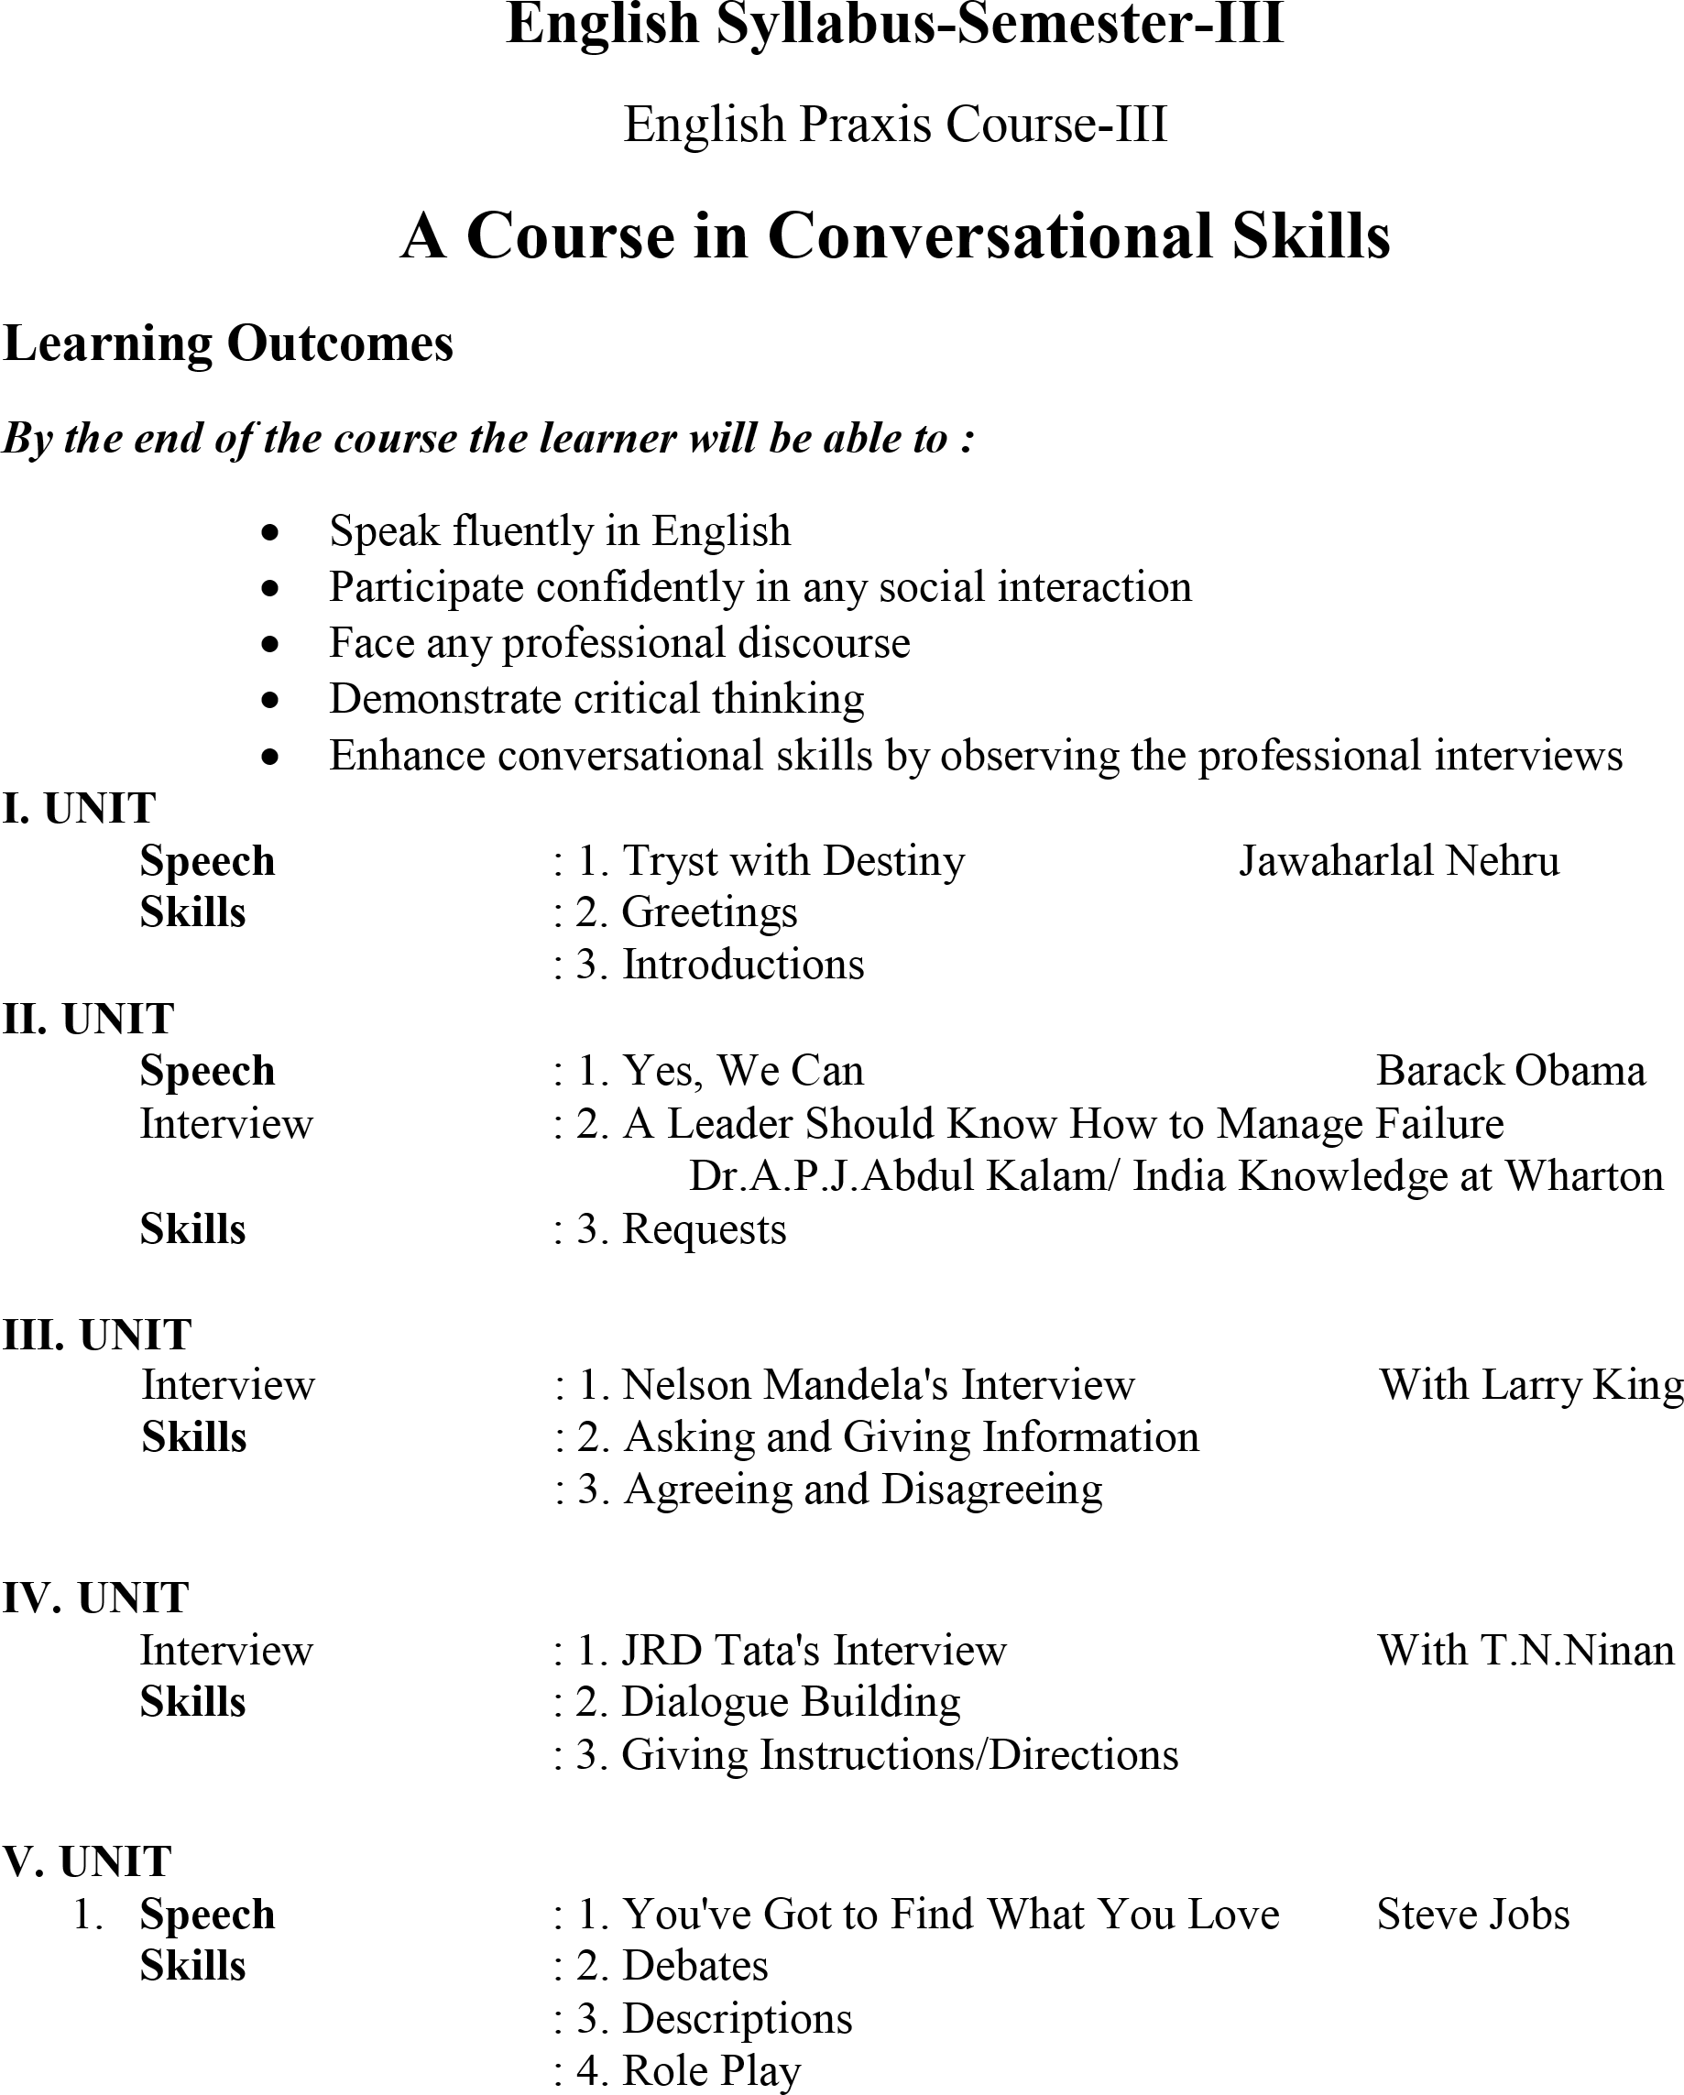

Academic Year: 2020-21
PVKN.Govt.College(A), Chittoor.
Department of English
B.A/B.Sc/B.Com SEMESTER-I
English Praxis Course-I
A Course in Communication and Soft Skills
20-ENG-101
AUTONOMOUS SYLLABUS

Learning Outcomes: By the end of the course the learner will be able to :
- Understand the importance of listening and develop listening skill.
- Use grammar effectively in writing andspeaking.
- Demonstrate the use of goodvocabulary
- Demonstrate an understating of writingskills
- Acquire ability to use Soft Skills in professional and dailylife.
- Confidently use the tools of communicationskills

I. UNIT: ListeningSkills
- Importance and types of listening
- Barriers toListening
- Measures forEffectiveListening

II. UNIT: SpeakingSkills
- Sounds of English: Vowels andConsonants
- Syllables
- Stress

III. UNIT:Writing
- Punctuations
- Paragraph writing using hints
- Jumbled sentences.

IV. UNIT: SoftSkills
- SWOC
- Attitude
- EmotionalIntelligence

V. UNIT:Grammar
- Articles
- Prepositions
- Tenses(Present/Past/Future)

PVKN Govt. College(A), Chittoor Three Year B.A/B.Sc/B.Com Degree Examination UG Second Semester Choice Based Credit System
English Praxis Course-II: A Course in Reading & Writing Skills
Paper code: 20-ENG-201 Autonomous syllabus
I UNIT
Skills : 1.Vocabulary: Conversion of Words:
2. One Word Substitutes:
3. Collocations

II UNIT
Poetry | : 1. Ode to the West Wind | PBShelley
Non-Detailed Text | : 2.FlorenceNightingale | Abrar Mohsin
Skills | : 3.SkimmingandScanning

III UNIT
Prose | :1.TheNightTrain at Deoli | Ruskin Bond
Skills | : 2. Reading Comprehension  : 3. Note Making/Taking
IV.UNIT  Poetry | :1.CoromandelFishers | Sarojini Naidu
Skills | :2.ExpansionofIdeas  3.Notices, Agendas and Minutes

UNIT
Non-Detailed Text : 1. An Astrologer's Day -RK Narayan
2 . Curriculum Vitae and Resume:
3. Letters &E-Correspondence

PVKN Govt. College(A), Chittoor.
Department of English
B.A/B.Sc/B.Com SEMESTER-III
English Praxis Course-III
A Course in Conversation Skills
Paper Code: 20-ENG-301
Learning Outcomes
By the end of the Course the learner will be able to:
- Speak fluently in English
- Participate confidently in any social interaction
- Face any professional discourse
- Demonstrate critical thinking
- Enhance conversational Skills by observing the professional Interviews
I. Unit
Speech Skills : 1. Pleasure of Books William Lyon Phelps
2.Greetings
3. Introductions
II. Unit
Reading Skills 1.Reading an Advertisement
2.A Leader Should Know How to Manage Failure:
Dr.A.P.J.Abdul Kalam/ India Knowledge at Wharton
3.Requests
III.Unit
Interview Skills :1.Interview Skills – Do’s and Don’ts
2. Asking and Giving Information
3.Agreeing and Disagreeing
IVUNIT
Writing Skills :1. Filling Forms(Bus Pass, Railway Reservation Form, Bank fill-in-Form
2. Dialogue Writing
3. Giving Instructions/Directions

V UNIT
Reading : 1.Reading a Diagram
Writing : 2.Picture Description
Grammar 3. Correction of Sentences

Academic Year 2019-20
PVKN.Govt.College(A), Chittoor.
Department of English
B.A/B.Sc/B.Com SEMESTER-I
English Praxis Course-I
A Course in Communication and Soft Skills
19-ENG-101
AUTONOMOUS SYLLABUS

Learning Outcomes: By the end of the course the learner will be able to :
- Understand the importance of listening and develop listening skill.
- Use grammar effectively in writing andspeaking.
- Demonstrate the use of goodvocabulary
- Demonstrate an understating of writingskills
- Acquire ability to use Soft Skills in professional and dailylife.
- Confidently use the tools of communicationskills

I. UNIT: ListeningSkills
- Importance and types of listening
- Barriers toListening
- Measures forEffectiveListening

II. UNIT: SpeakingSkills
- Sounds of English: Vowels andConsonants
- Syllables
- Stress

III. UNIT:Writing
- Punctuations
- Paragraph writing using hints
- Jumbled sentences.

IV. UNIT: SoftSkills
- SWOC
- Attitude
- EmotionalIntelligence

V. UNIT:Grammar
- Articles
- Prepositions
- Tenses(Present/Past/Future)

PVKN Govt. College(A), Chittoor Three Year B.A/B.Sc/B.Com Degree Examination UG Second Semester Choice Based Credit System
English Praxis Course-II: A Course in Reading & Writing Skills
Paper code: 19-ENG-201 Autonomous Syllabus
I UNIT
Skills : 1.Vocabulary: Conversion of Words:
2. One Word Substitutes:
3. Collocations

II UNIT
Poetry | : 1. Ode to the West Wind | PBShelley
Non-Detailed Text | : 2.FlorenceNightingale | Abrar Mohsin
Skills | : 3.SkimmingandScanning

III UNIT
Prose | :1.TheNightTrain at Deoli | Ruskin Bond
Skills | : 2. Reading Comprehension  : 3. Note Making/Taking
IV.UNIT  Poetry | :1.CoromandelFishers | Sarojini Naidu
Skills | :2.ExpansionofIdeas  3.Notices, Agendas and Minutes

UNIT
Non-Detailed Text : 1. An Astrologer's Day -RK Narayan
2 . Curriculum Vitae and Resume:
3. Letters &E-Correspondence

PVKN Govt. College(A), Chittoor.
Department of English
B.A/B.Sc/B.Com SEMESTER-III
English Praxis Course-III
A Course in Conversation Skills
Paper Code: 19-ENG-301
Learning Outcomes
By the end of the Course the learner will be able to:
- Speak fluently in English
- Participate confidently in any social interaction
- Face any professional discourse
- Demonstrate critical thinking
- Enhance conversational Skills by observing the professional Interviews
I. Unit
Speech Skills : 1. Pleasure of Books William Lyon Phelps
2.Greetings
3. Introductions
II. Unit
Reading Skills 1.Reading an Advertisement
2.A Leader Should Know How to Manage Failure:
Dr.A.P.J.Abdul Kalam/ India Knowledge at Wharton
3.Requests
III.Unit
Interview Skills :1.Interview Skills – Do’s and Don’ts
2. Asking and Giving Information
3.Agreeing and Disagreeing
IVUNIT
Writing Skills :1. Filling Forms(Bus Pass, Railway Reservation Form, Bank fill-in-Form
2. Dialogue Writing
3. Giving Instructions/Directions

V UNIT
Reading : 1.Reading a Diagram
Writing : 2.Picture Description
Grammar 3. Correction of Sentences

Academic Year: 2018-19

