COMMISSIONERATE OF COLLEGIATE EDUCATION GOVERNMENT OF ANDHRA PRADESH
Template/Guidelines for Monthly College Newsletter
PVKN CAMPUS ROOTS
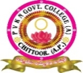 PVKN GOVERNMENT COLLEGE(A) CHITTOOR 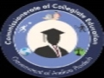
MOTTO: Learn Today – Lead Tomorrow
VISION: “Aims to lead social Progress by Promoting equality and education.”
MONTH: NOVEMBER YEAR: 2024
PRINCIPAL’S MESSAGE
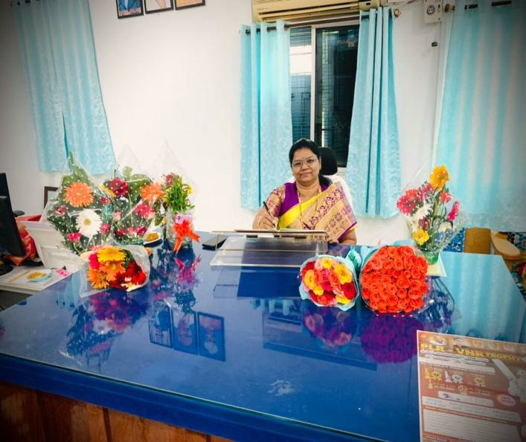
Education is an essential ornament that can lead to our success. Life brings to us different challenges and education helps us in dealing with those challenges in a better way. Education raises the individual to a higher level of awareness and understanding. It provides a person with a unique standard in life and also a feeling of well-being which differentiates human beings from other creatures.

Imparting Value Education is the prime objective of PVKN Govt College, Chittoor. The college has the potential to face the challenges of varied requirements of the students. This prestigious institution has got all the paraphernalia which provides an amicable and congenial atmosphere to achieve the targeted goals.
EDITORIAL BOARD | 1. Dr. P. JEEVAN JYOTHI, Principal
EDITORIAL BOARD | 2.Sri M. AJJANNA, Lecturer in English

CONTENTS
Sl. No | Titles | Page No
1 | Awareness programme on Women Help line services | 3-4
2 | Dr. C.V. Raman’s birth anniversary celebration | 5
3 | Inter Collegiate Youth Festival | 6
4 | YUVA UTSAV-24 | 7
5 | C.P. BROWN JAYANTHI celebrations | 7-8
6 | Blood Donation Campaign | 8-9
7 | Wealth Laying Ceremony | 10-11
8 | National Constitutional Day | 12-13
9 | Extension Programme – Faculty of Physics | 13-15
10 | awareness activity on "Food Adulteration of Toor Dal with Kesari Dal | 15-19

Awareness programme
On
“Women Help line services Toll free number”
Women empowerment Cell
Date: 01-11-2024
Brief Report: The primary purpose of Woman Empowerment Cell of PVKN to conduct “Awareness programme on Women Help line services” with Toll free numbers, collaborating with Mahila police station, Chittoor.
The objective of this programme is to provide knowledge to women students how to access 24/7 women safety services through a single call. Help lines thus provide immediate and emergency response to women affected by violence through referral and other information about women related government schemes. Students actively participated and clarified their doubts with resource persons.
Help line no: 1098 – Child Help line,
181 – Women Help Line
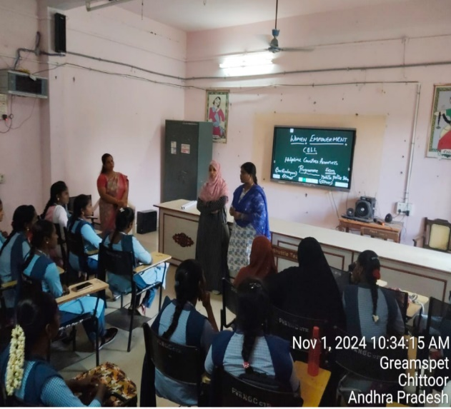
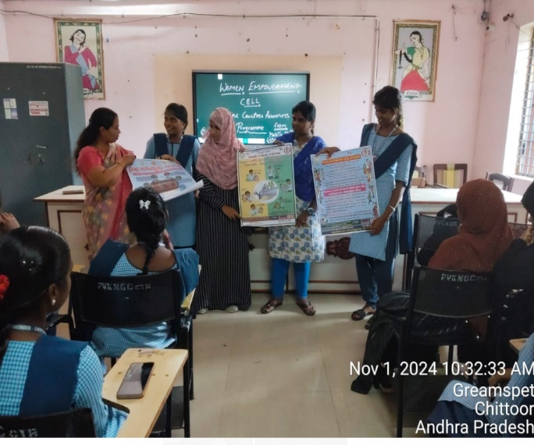
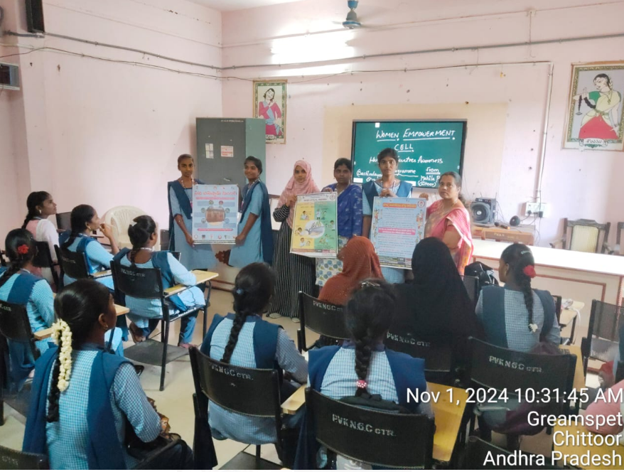

Sir C.V. Raman Birth Anniversary Celebrations
Department of Physics and Electronics
Date: 07-11-2024
The Department of Physics and Electronics at PVKN Govt. College (A) commemorated the Birth Anniversary of the renowned Indian Physicist and Nobel laureate, Dr. C.V. Raman, on November 7, 2024, with immense enthusiasm and respect. The event was organized to celebrate his remarkable contributions to science, especially his revolutionary discovery of the Raman effect.
The celebrations began with a inaugural session presided over by the attendees, including COE, faculty and students. The head of the department delivered the welcome address, emphasizing the relevance of Raman’s discoveries in Modern Physics. COE and the faculty gave an inspiring speech, highlighting the lifestyle and achievements of Dr. C.V. Raman and his groundbreaking contributions to the field of science.
The celebrations of Dr. C.V. Raman’s birth anniversary left a lasting impression on the students, inspiring them to pursue scientific curiosity and innovations, carrying forward his remarkable legacy.
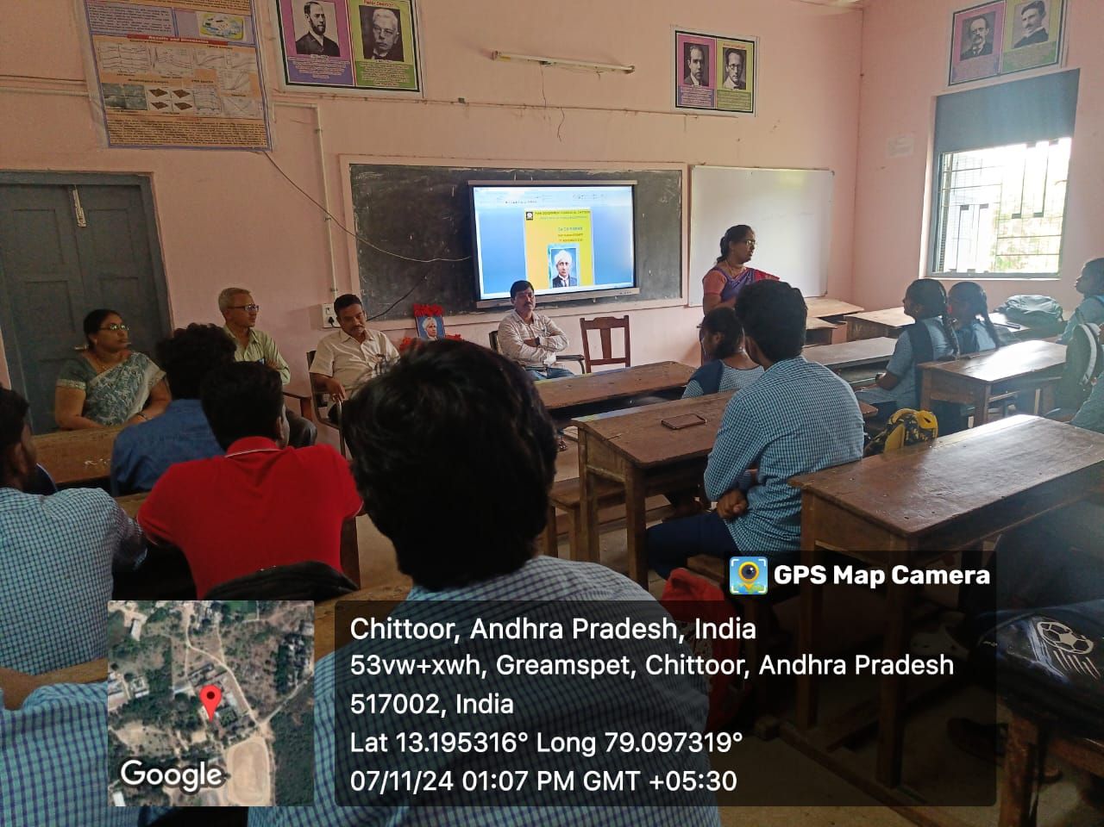
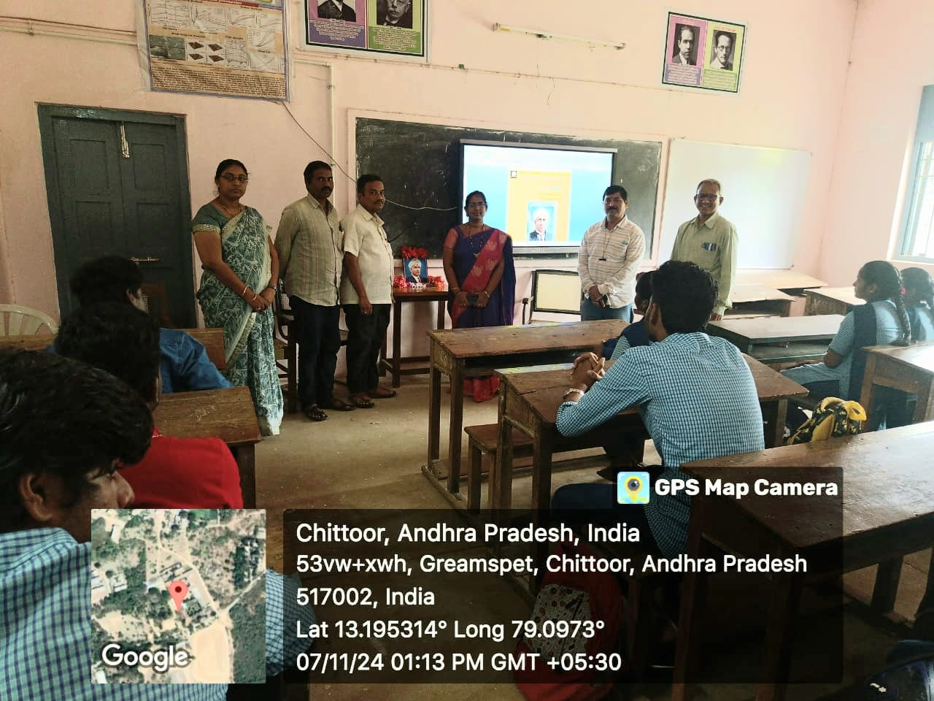

DEPARTMENT OF TELUGU
COLLEGE CULTURAL ACTIVITIES
INTER COLLEGIATE YOUTH FESTIVAL
Date: 08th, 9th & 10th November 2024
Sri Venkateswara University Cultural Department organized Inter Collegiate Cultural competitions named “YUVATARANG-24” in different aspects. Our college students participated in some events. E. Naranjan I B.Sc(Computer Science) participated and got the 1st PRIZE in “Spot Painting”. It is one of the best achievements of our students at University Level Competitions. The principal and the staff appreciate the student.
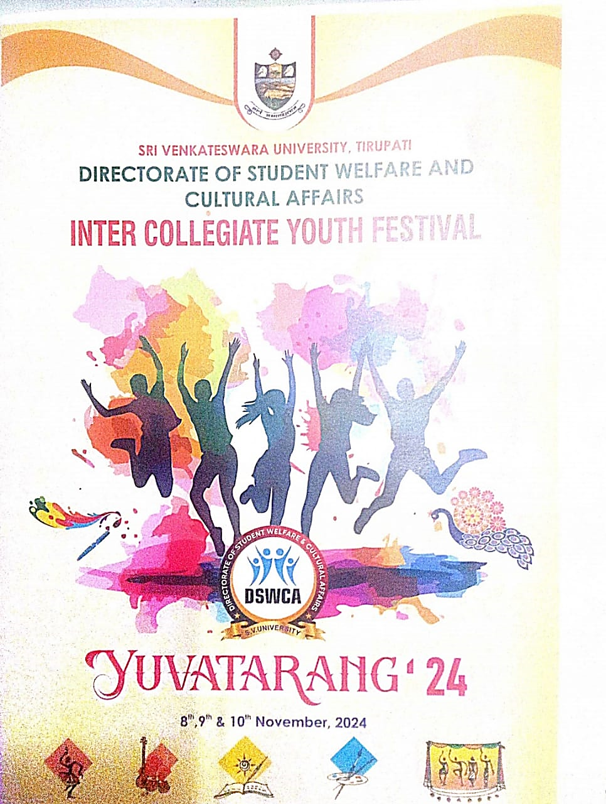
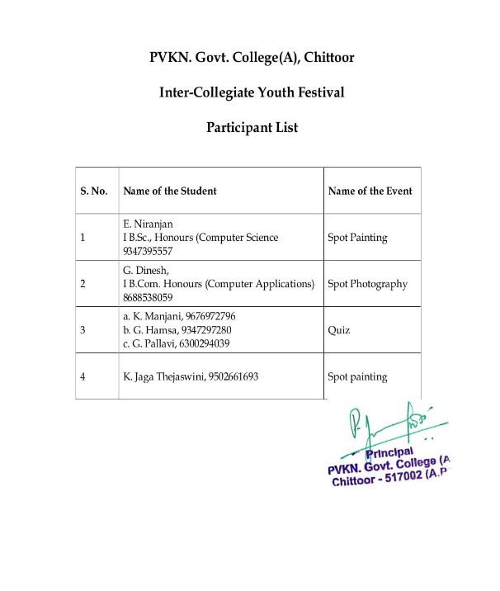
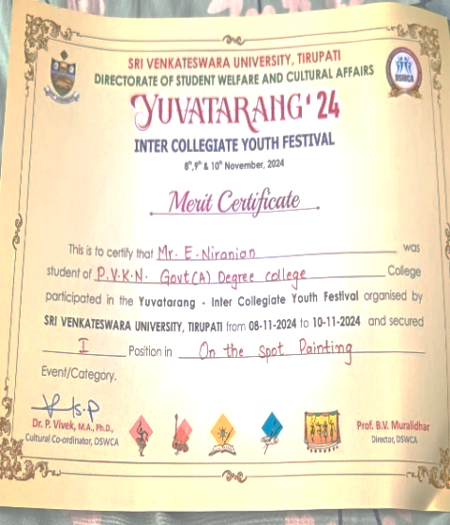
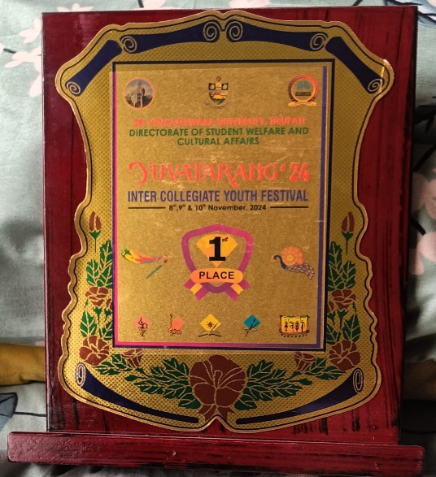

YUVA UTSAV - 2024
26 -November-2024

Nehru Yuva Kendra, Chittoor- Ministry of Youth Affairs & Sports, Govt. of India organized inter e Cultural competitions named “YUVA UTSAV-24” in different aspects. Our college students participated in Cultural events.

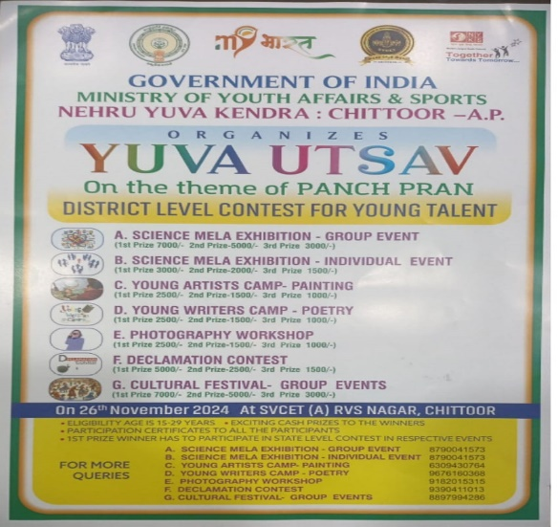
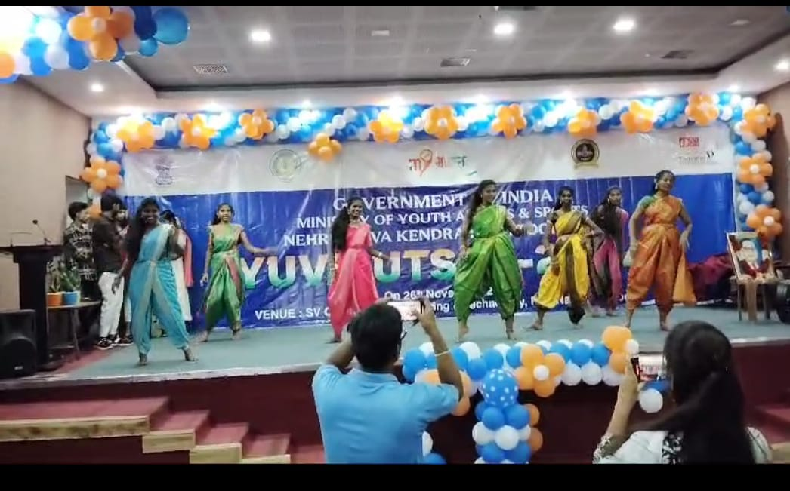

C. P. BROWN JAYANTHI
DEPARTMENT OF TELUGU
DATE: 11-11-2024

C.P. BROWN JAYANTHI celebrations conducted by Department of Telugu on 11.11.2024. Dr. P. C. CHENNAKESAVULU LECTURER In Charge, Department of Telugu preside over the function. SRI B. GOPIRYA NAICK, Lecturer in Telugu, Dr. P. JAYACHANDRUDU, Lecturer in Telugu spokes about the life and works of C.P. BROWN. students also spoke about C.P. BROWN. Students are actively participated in this programme.
Students learn about C. P. BROWN works on Telugu Literature and his effect on Telugu Literature.

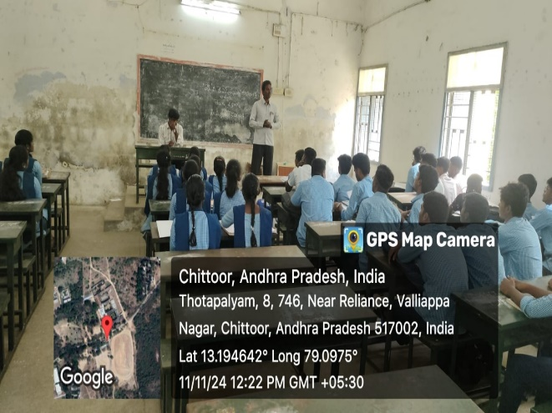
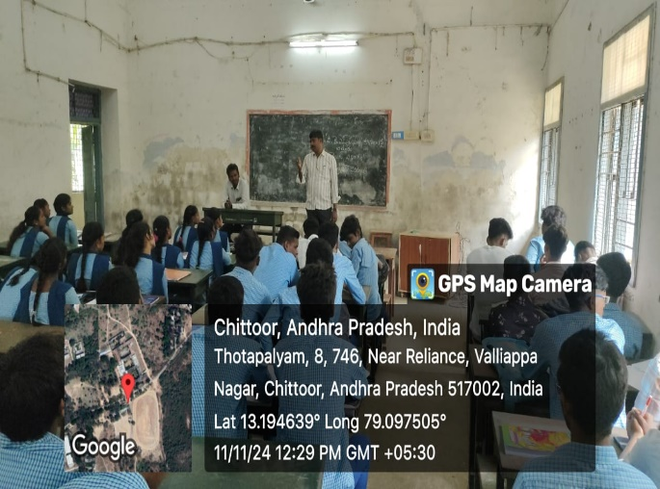

NCC ACTIVITY-NOVEMBER 2024
Blood Donation campaign
DATE: 22-11-2024
The National Cadet Corps (NCC) will commemorate its 76th anniversary with a blood donation drive under the theme “Rakt Daan Jeevan Daan” on November 22. The event will take place at P.V.K.N. Government College (A), Chittoor, from 10:00 AM to 12:00 Noon. This initiative underscores NCC's commitment to social service and community well-being.

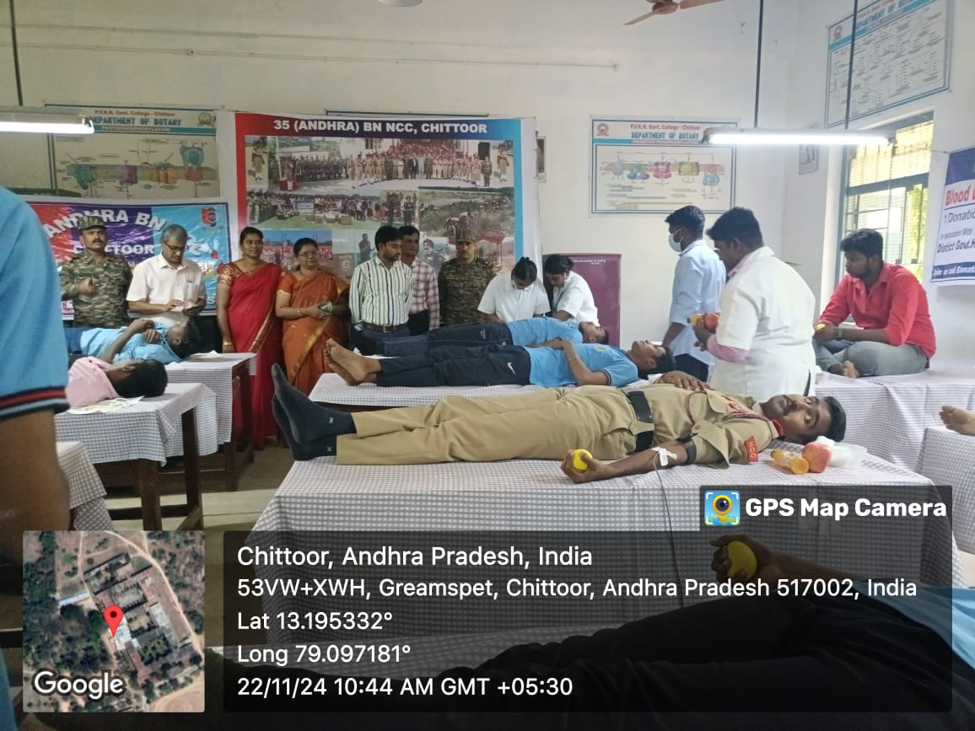
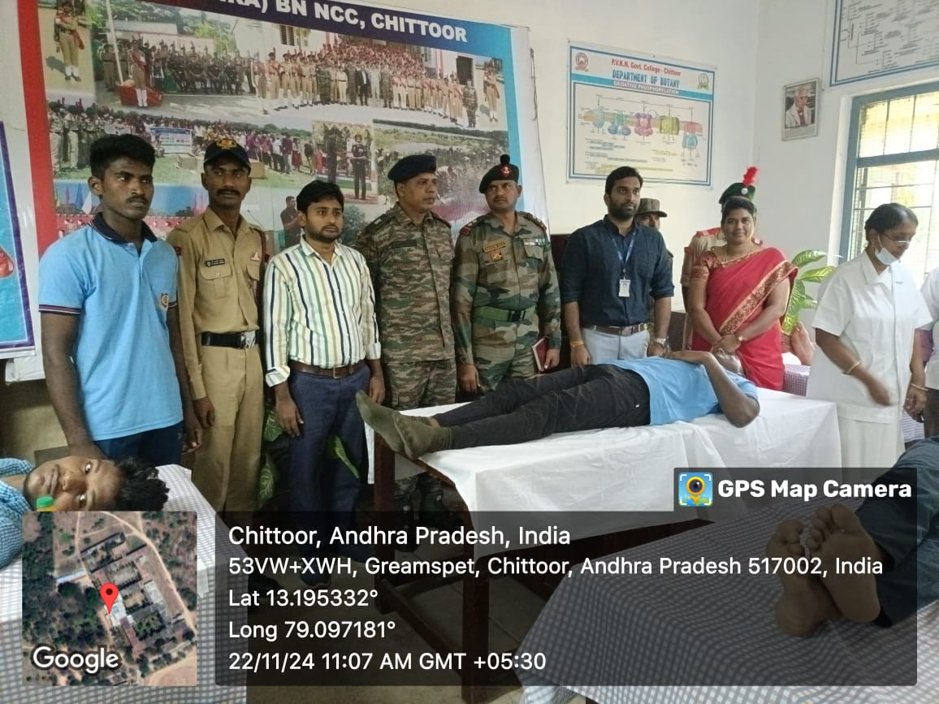

NCC ACTIVITY-NOVEMBER 2024
Wreath Laying Ceremony
DATE: 23-11-2024
On November 23, 2024, the 35 A Coy NCC P.V.K.N Cadets of PVKN College participated in the Wreath Laying Ceremony held at the War Memorial in Chittoor to mark NCC Day.
In a solemn tribute, Commanding Officer Colonel Ajay N.V. Monish, Administrative Officer Major Ranganathan, and the NCC cadets laid a wreath to honor the memory of fallen heroes. This act of reverence represented the collective gratitude and respect of the entire 35(A) Bn NCC unit fraternity. The event underscored the cadets' commitment to the values of discipline, service, and sacrifice upheld by the National Cadet Corps.
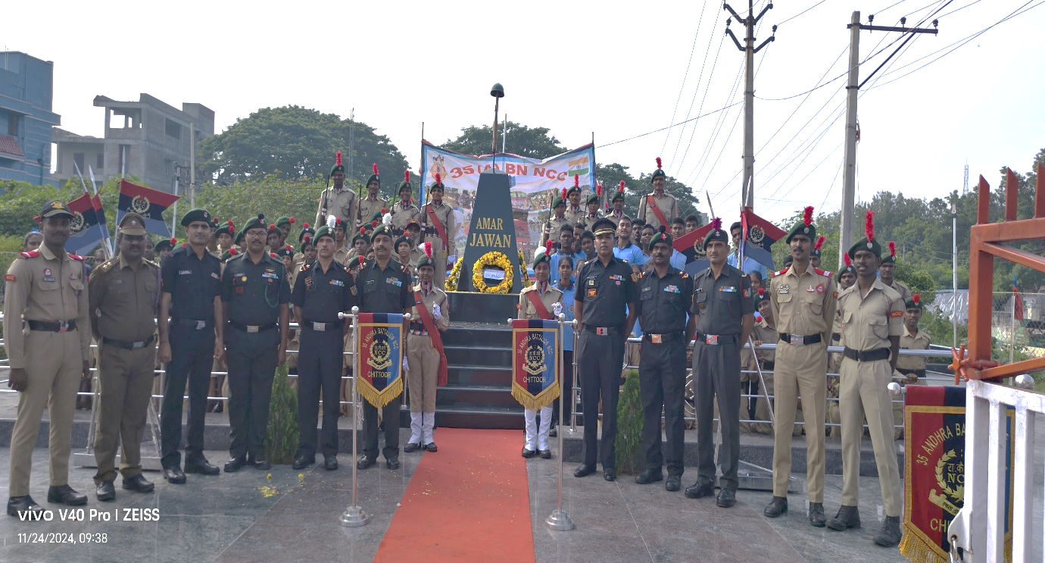
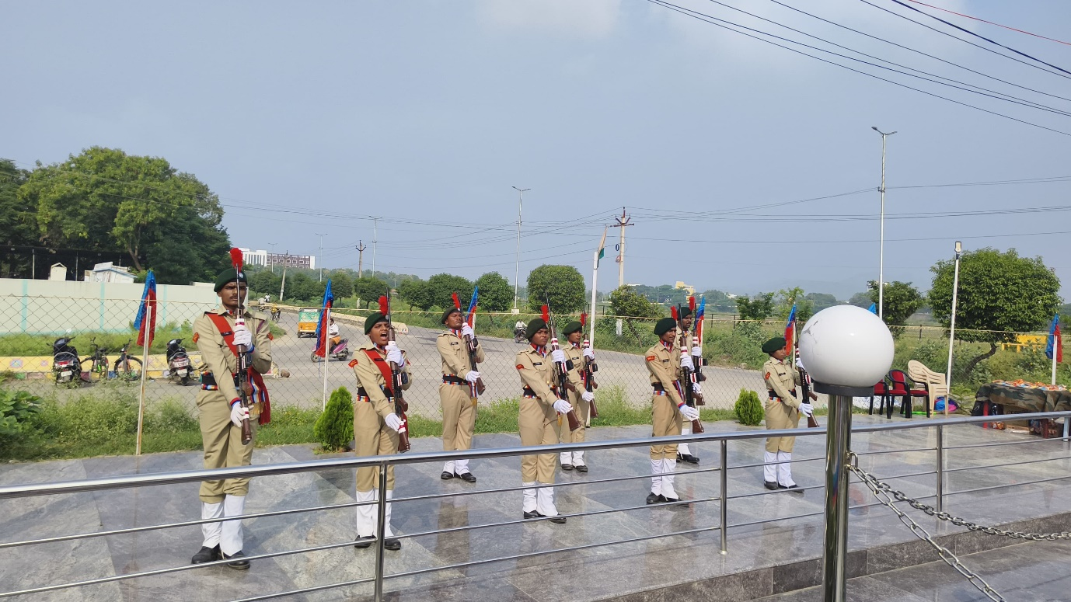
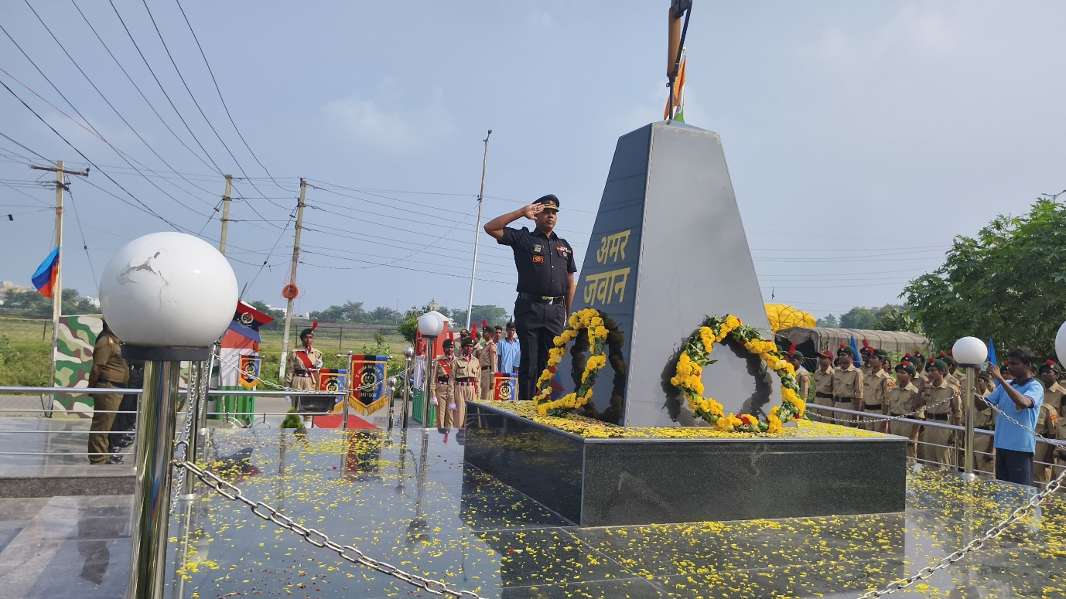

NATIONAL CONSTITUTIONAL DAY Department of Political Science
DATE: 26-November 2024

Brief Report: The speaker & President of the programme Dr. P. Jeevan Jyothi and Staff members assembled at prayer hall with students to follow the Pledge at College Campus and also Quiz competition conducted in Room no; 125 between 11.30 to 1 pm for all students.

Programme outcomes:
- Constitution and history of constitution
- People behind Constitution of India
- Role of Judiciary in Constitution
- Procedure for amending constitution
- Basic rights and responsibilities of Indian citizen as per our constitution
- Preamble of constitution
- Challenges for Constitution of India
- The speaker read out the preamble and explained the history

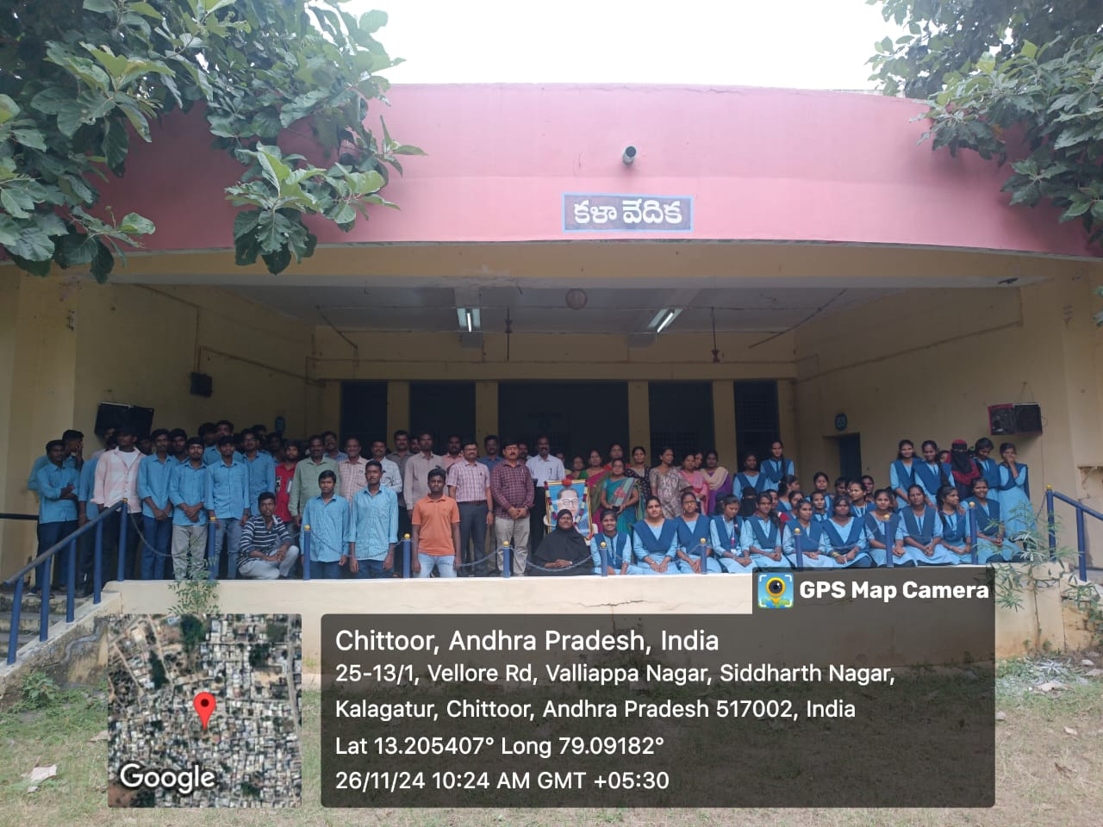

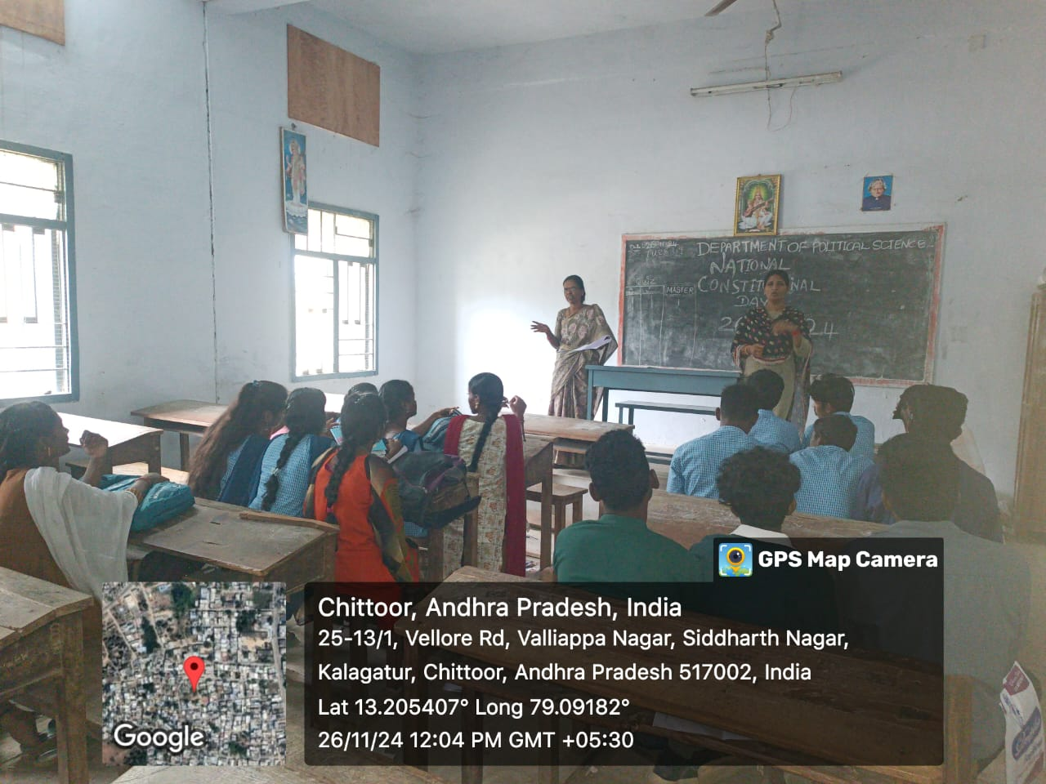

EXTENSION PROGRAMME
Department of Physics and Electronics
From PVKN College(A) to NPS College(A), Chittoor
DATE: 25-11-2024 to 30-11-2024
The Physics faculty of PVKN College extended their expertise by conducting Physics classes at NPS College as part of a collaborative academic initiative. This program aimed to strengthen inter-collegiate cooperation and enhance the learning experience for students at NPS College.

Program Details
Duration: One week (from 25-11-2024 to 30-11-2024)
Faculty Involved
- Dr. P. Mallika Bramaramba Devi
- Dr. G. Sudhakar
- Dr. G. Udaya Bhaskara Reddy
- Sri B. Rama Sagar
- Sri G. Raveendra Babu
- Smt. A. Navaneetha
Student Participation: The students of NPS College actively participated in the sessions. They appreciated the faculty’s teaching approach, which included interactive discussions, real-world applications, and problem-solving exercises.

Outcome
The collaborative teaching initiative proved to be highly beneficial for both institutions. The program highlighted the commitment of PVKN College’s Physics department to promote quality education and foster academic excellence through collaboration.
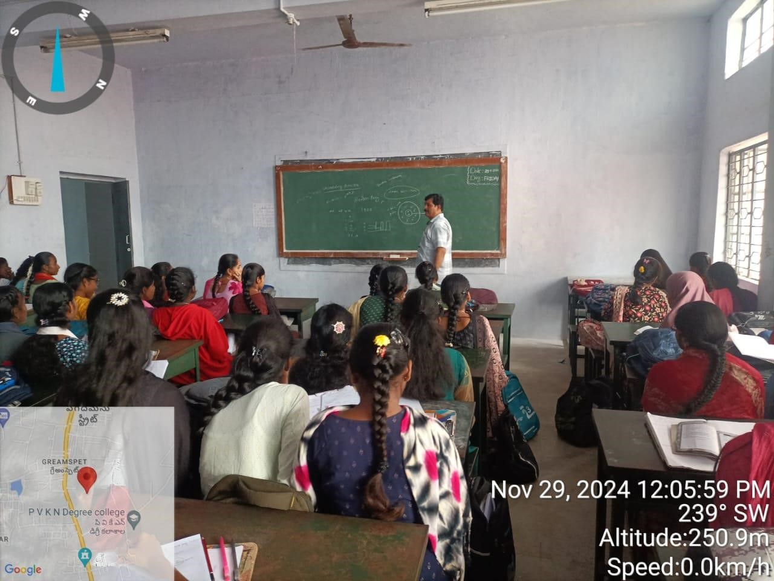
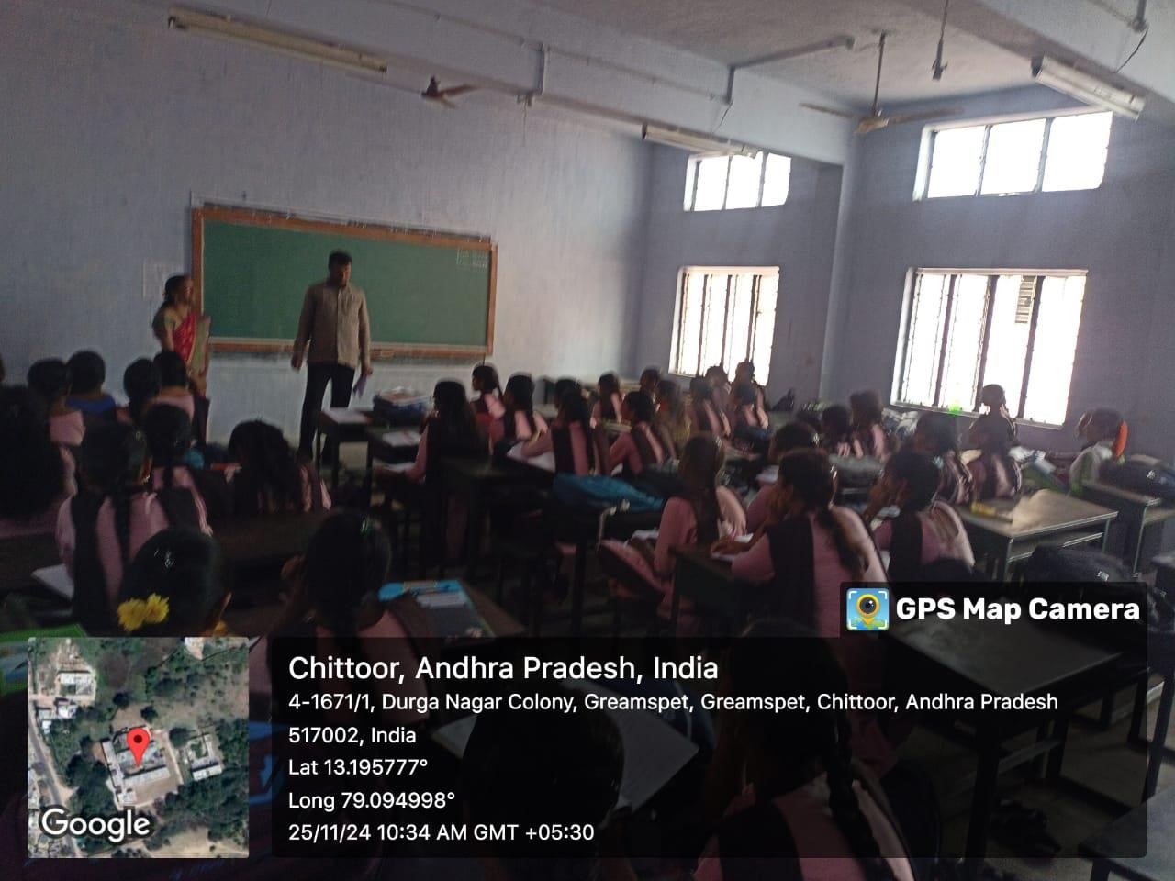
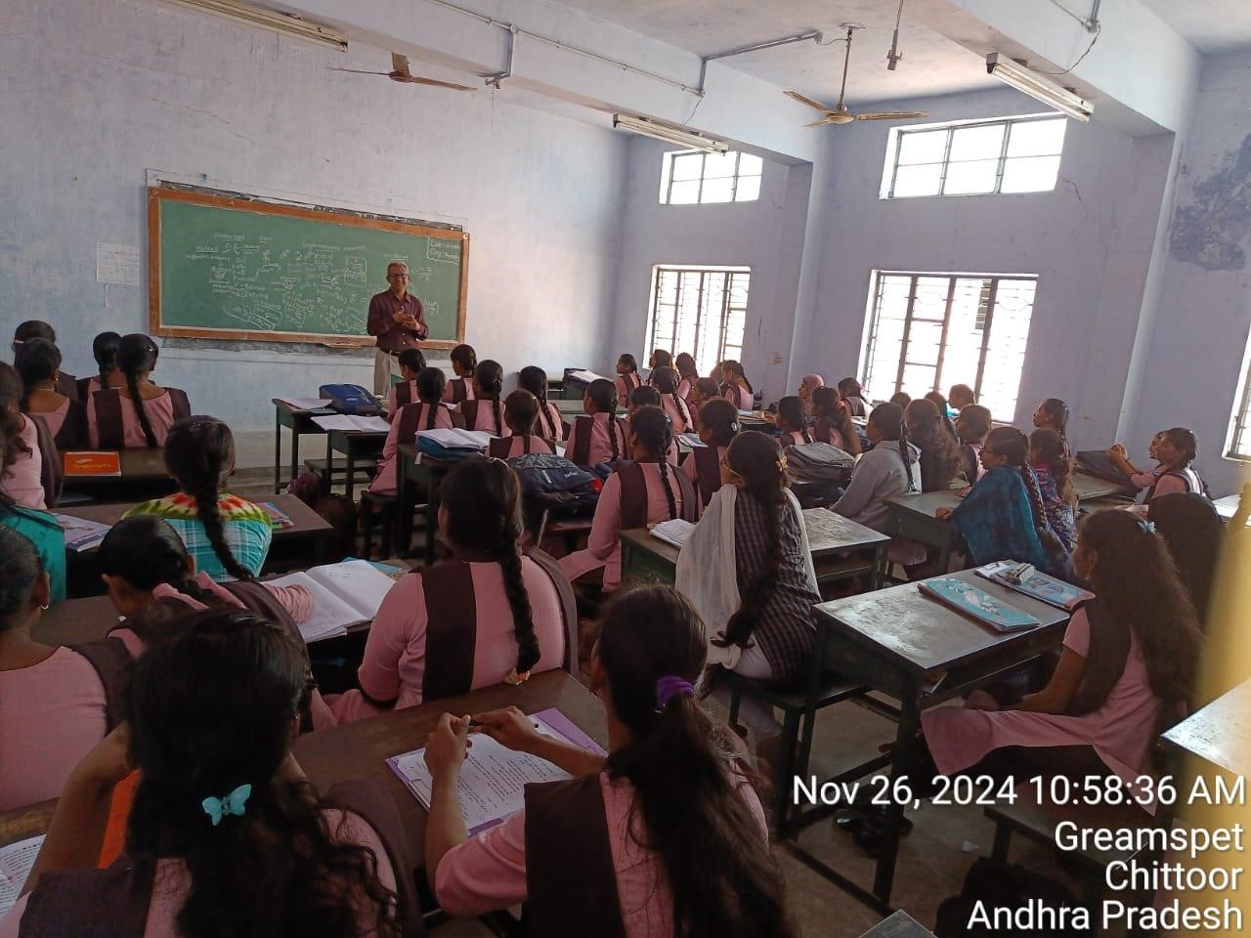
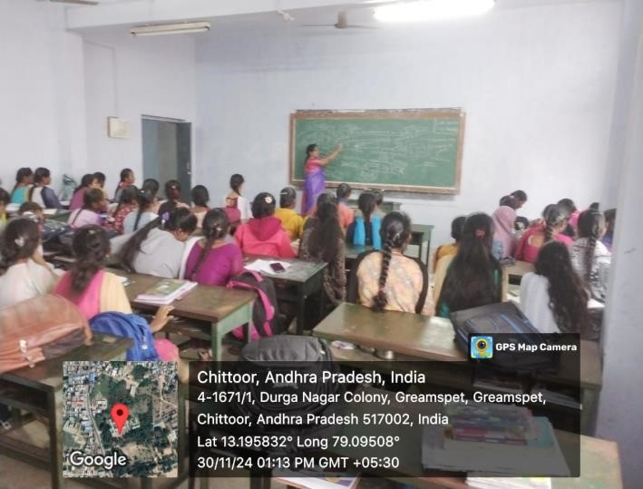

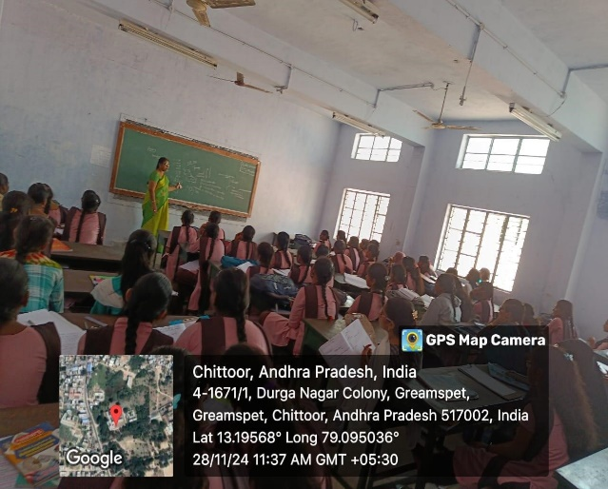
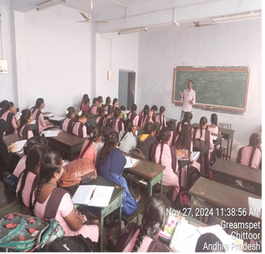

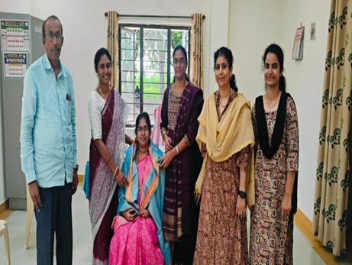
Dr. P. Mallika Bramaramba Devi, Incharge of the Physics Dept has felicitated by the Principal, NPSW College (A), Chittoor.
AWARENESS ACTIVITY
FOOD ADULTERATION OF TOOR DAL WITH KESARI DAL
Department of Chemistry
30-11-2024
Introduction:
As part of community engagement initiatives, The Department of Chemistry organized an awareness activity on "Food Adulteration of Toor Dal with Kesari Dal". This activity aimed to educate the staff and students about the harmful effects of adulteration, focusing specifically on the adulteration of Toor Dal (pigeon pea) with Kesari Dal (lathyrus pea).
Event Details:
- Date: 30th November, 2024
- Location: All Departments of the College
- Activity Coordinator: Dr P. Bhanuprakash
- Name of the Lecturers involved: Lt. A. Ramesh, Dr. D. Srividya,
Sri A. Kumar Raja, Sri M. Mallikarjuna Reddy
- Participants: 20 Chemistry Hons. students have participated in the awareness rally
Objectives:
- Highlight the risks of food adulteration on health.
- Explain how Kesari Dal, when consumed over time, can lead to health issues such as lathyrism, which affects the nervous system.
- Explain simple tests to detect adulteration Toor Dal with Kesari Dal using physical appearance.
Brief Report:
The department of Chemistry organized an awareness activity on "Food Adulteration of Toor Dal with Kesari Dal". Kesari dal is often used to adulterate other dals because it looks similar. Kesari dal is square-like in shape with a slant on one side, giving it an edged appearance. Consuming food adulterated with Kesari dal can cause serious health issues, including Paralysis, Lung failure, Stomach issues and Lathyrism, a neuron disorder that causes paraparesis of the lower limbs.
Students delivered an engaging presentation explaining the chemical composition of Toor Dal and Kesari Dal, focusing on why Kesari Dal is used as an adulterant and its harmful effects. Explained simple methods to detect Kesari Dal in Toor Dal using physical appearance. Leaflets containing information about food adulteration, its impacts, and easy detection methods were distributed to the faculty members and students of the college.
Outcomes:
- Increased awareness among staff and students about the harmful effects of adulterated Toor Dal.
- Encouraged staff and students to demand unadulterated food products while purchasing.
Conclusion:
The B.Sc. Chemistry students successfully raised awareness about the adulteration of Toor Dal with Kesari Dal, its impacts, and its easy detection method. The activity not only enhances students' learning experience but also fulfill their social responsibility.

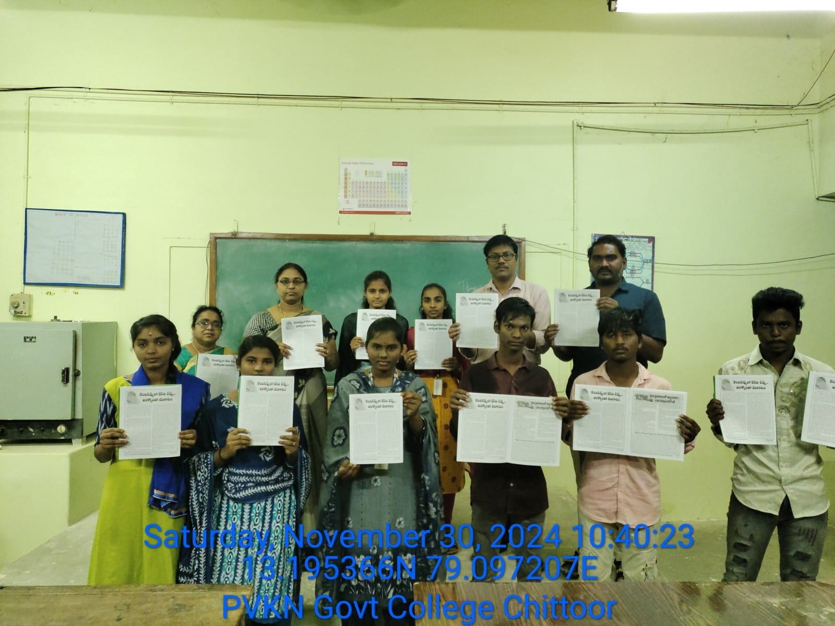
(Leaflets containing information about adulteration of Toor Dal with Kesari Dal,
its impacts, and easy detection method were distributed to the Science students)
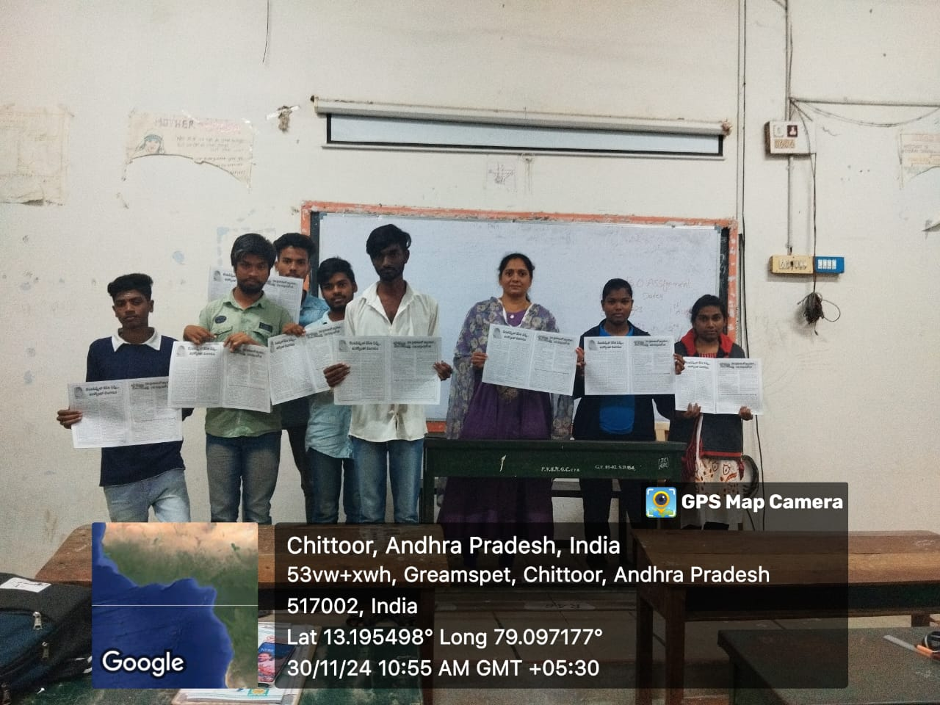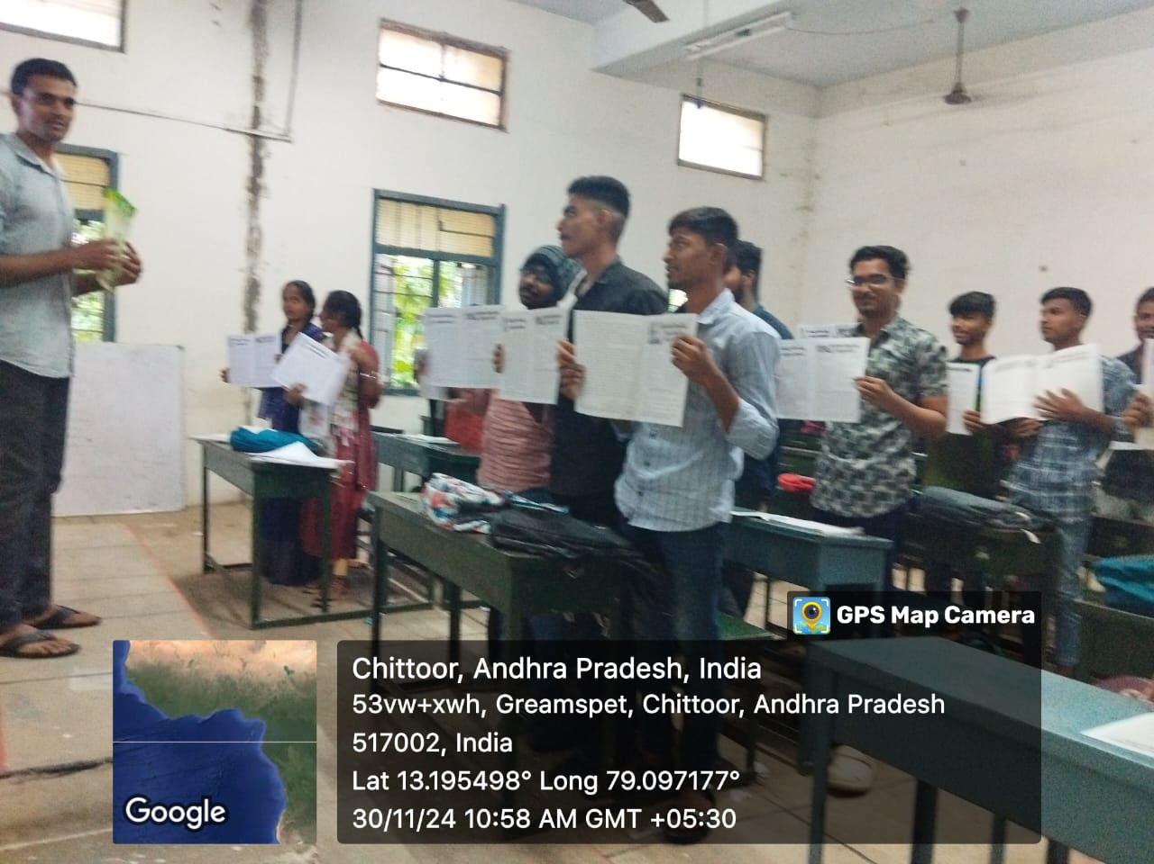
(Leaflets containing information about adulteration of Toor Dal with Kesari Dal, its impacts, and easy detection method were distributed to the Commerce students)
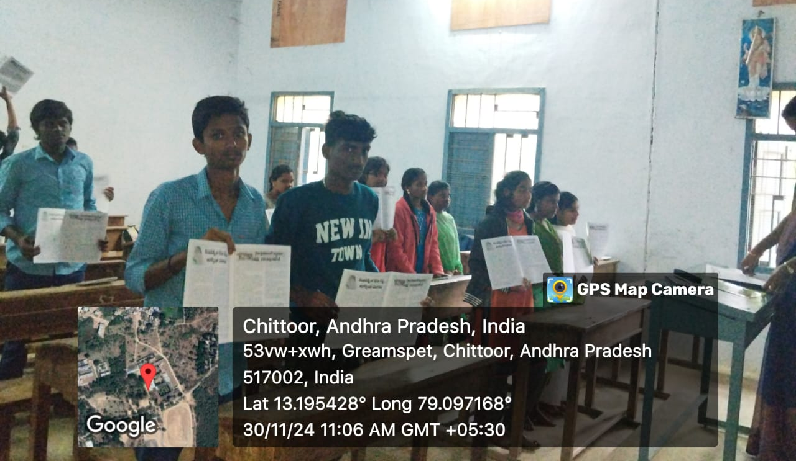
(Leaflets containing information about adulteration of Toor Dal with Kesari Dal,
its impacts, and easy detection method were distributed to the Arts students)

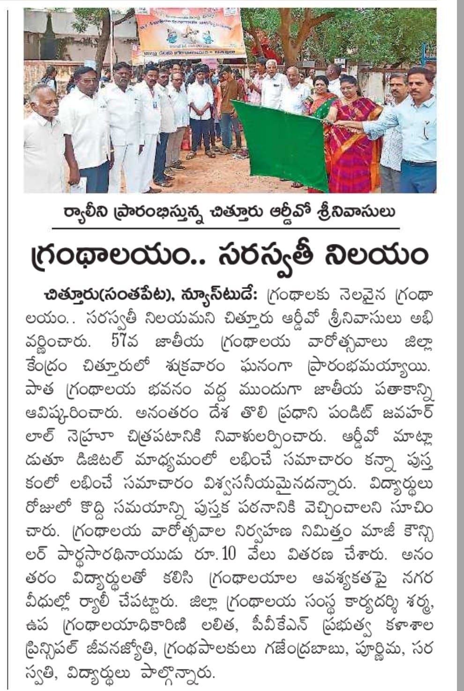
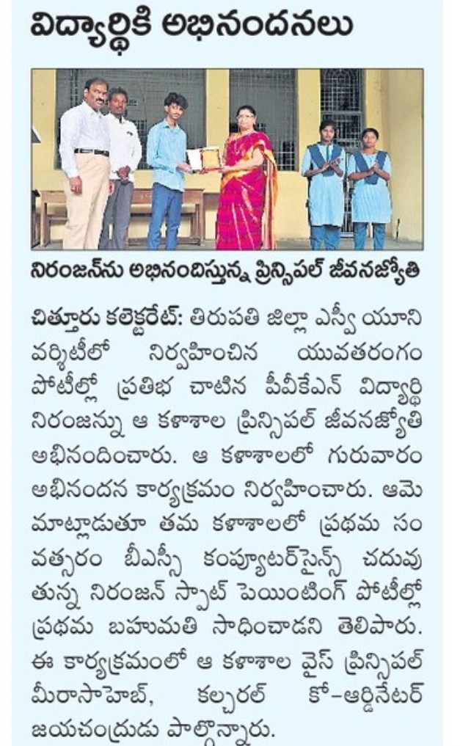
PAPER CLIPPINGS

